JENKINS SETUP

1.Login to the Jenkins dashboard using username and password.

2.Go to the manage Jenkins and click on plugins manager.

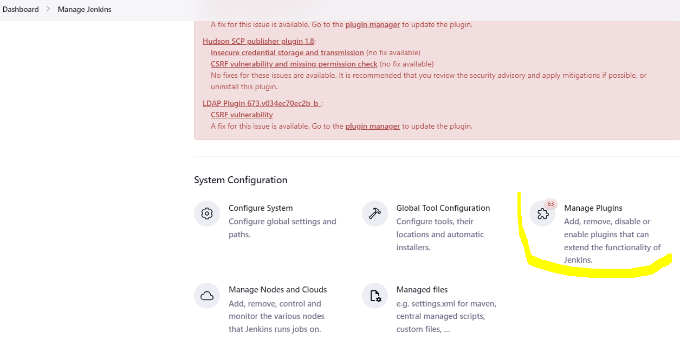

3.Install the required plugins based on requirements like java and nodejs.

4.Also install nodejs or java in the server using following command.

Sudo yum install nodejs

5.Go to the manage Jenkins and click on configure system.

5.Add the remote server username and private key as shown in the below figure.

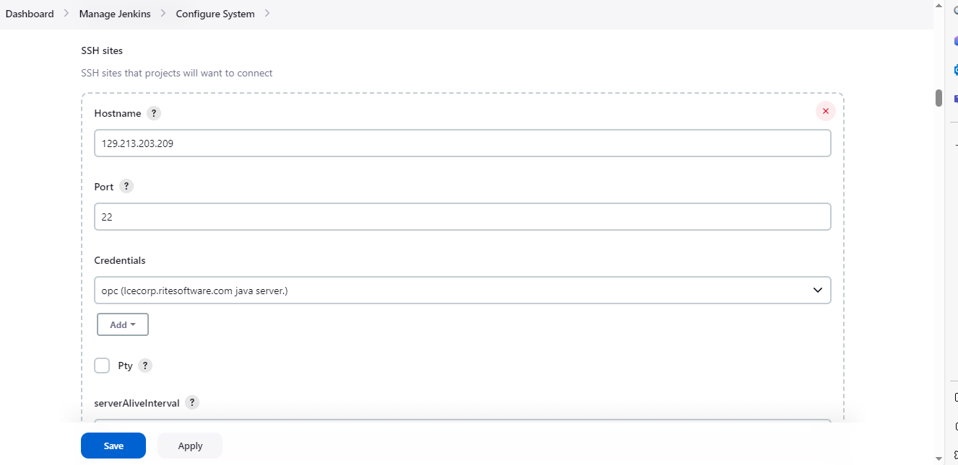

6. In the manage Jenkins section, click on Global tool configuration and add the node js configuration as shown below.

7.In the dashboard click on new item .

8.click on maven project and save it.

9.Go to the selected project and click on configure.

10.In the pipeline section, add the script as per the requirements.

a. first clone the code from the github.

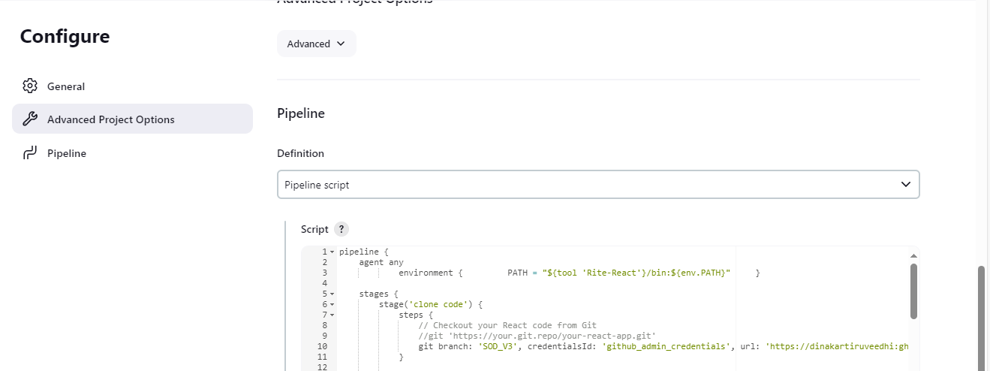

11. Build the code using relevant tools and frameworks.

13.Deploy the code to the remote server using ssh.

Click on save and apply.

Later click on build in the dashboard .

